Web Technologies and Applications
Assignment
992401040104 Ajitesh Rajput
Q1
Index.jsp
<%@ page language="java" contentType="text/html; charset=UTF-8"
pageEncoding="UTF-8"%>
<!DOCTYPE html>
<html>
<head>
<meta charset="UTF-8">
<title>Q1</title>
</head>
<body>
<form method="POST" action="aq1">
NAME:<input type="text" name="name">
<BR><BR>
Number:<input type="text" name="number">
<br><br>
UNITS:<INPUT typr="text" name="unit">
<br><br>

<input type="submit" name="submit">
</form>
</body>
</html>

Servlet

import java.io.IOException;

import javax.servlet.RequestDispatcher;
import javax.servlet.ServletConfig;
import javax.servlet.ServletException;
import javax.servlet.annotation.WebServlet;
import javax.servlet.http.HttpServlet;
import javax.servlet.http.HttpServletRequest;
import javax.servlet.http.HttpServletResponse;

/**
* Servlet implementation class aq1
*/
@WebServlet("/aq1")
public class aq1 extends HttpServlet {
private static final long serialVersionUID = 1L;

/**
* @see HttpServlet#HttpServlet()
*/
public aq1() {
super();
// TODO Auto-generated constructor stub
}

protected void doPost(HttpServletRequest request, HttpServletResponse response) throws ServletException, IOException {
// TODO Auto-generated method stub
String name=request.getParameter("name");
int number=Integer.parseInt(request.getParameter("number"));
int unit=Integer.parseInt(request.getParameter("unit"));

int cal=50*unit;
request.setAttribute("name", name);
request.setAttribute("number", number);
request.setAttribute("unit", unit);
request.setAttribute("amount", cal);
RequestDispatcher rd=request.getRequestDispatcher("response.jsp");
rd.forward(request, response);

}

}

Response.jsp
<%@ page language="java" contentType="text/html; charset=UTF-8"
pageEncoding="UTF-8"%>
<!DOCTYPE html>
<html>
<head>
<meta charset="UTF-8">
<title>Q1</title>
</head>
<body>

NAME: <%= request.getAttribute("name") %>
<br><br>
NUMBER: <%= request.getAttribute("number") %>
<br><br>
UNITS: <%= request.getAttribute("unit") %>
<br><br>
TOTAL COST: <%= request.getAttribute("amount") %>

</body>a
</html>

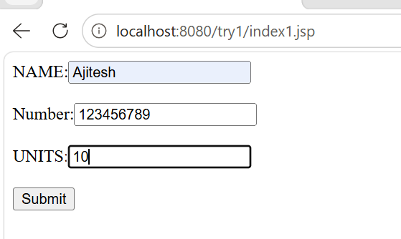
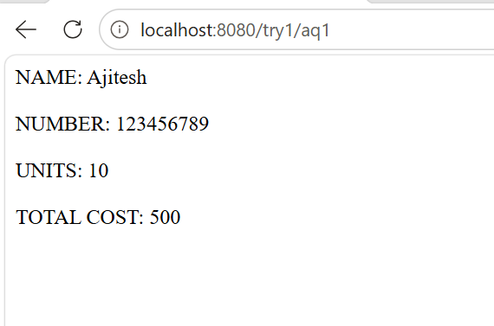

Q2
Header.jsp
<html>
<head>
<title>Student Grade Calculator</title>
</head>

<body>

<h1>Student Grade Calculation System</h1>

<hr>

Marks.jsp
<%@ page language="java" contentType="text/html; charset=UTF-8"
pageEncoding="UTF-8"%>
<!DOCTYPE html>
<html>
<head>
<meta charset="UTF-8">
<title>Insert title here</title>
</head>
<body>
<%@ include file="header.jsp" %>

<h2>Enter Student Details</h2>

<form action="result.jsp" method="post">

Student Name:
<input type="text" name="sname">

<br><br>

Subject 1:
<input type="text" name="m1">

<br><br>

Subject 2:
<input type="text" name="m2">

<br><br>

Subject 3:
<input type="text" name="m3">

<br><br>

Subject 4:
<input type="text" name="m4">

<br><br>

Subject 5:
<input type="text" name="m5">

<br><br>

<input type="submit" value="Calculate">

</form>

</body>
</html>
</body>
</html>

Result.jsp
<%@ page language="java" contentType="text/html; charset=UTF-8"
pageEncoding="UTF-8"%>
<!DOCTYPE html>
<html>
<head>
<meta charset="UTF-8">
<title>Insert title here</title>
</head>
<body>
<%@ include file="header.jsp" %>
<%!
double calp(int t){
return t/5.0;

}
String calculateGrade(double per) {

if(per >= 90)
return "A+";

else if(per >= 75)
return "A";

else if(per >= 60)
return "B";

else if(per >= 40)
return "C";

else
return "Fail";
}

%>

<%
String name =request.getParameter("sname");

int m1 = Integer.parseInt(request.getParameter("m1"));

int m2 = Integer.parseInt(request.getParameter("m2"));

int m3 = Integer.parseInt(request.getParameter("m3"));

int m4 = Integer.parseInt(request.getParameter("m4"));

int m5 = Integer.parseInt(request.getParameter("m5"));

int total =m1 + m2 + m3 + m4 + m5;

double per =
calp(total);

String grade =calculateGrade(per);
%>

<h2>Student Result</h2>

<table border="1" cellpadding="10">

<tr>
<th>Student Name</th>
<td><%= name %></td>
</tr>

<tr>
<th>Total Marks</th>
<td><%= total %></td>
</tr>

<tr>
<th>Percentage</th>
<td><%= per %>%</td>
</tr>

<tr>
<th>Grade</th>
<td><%= grade %></td>
</tr>

</table>
</body>
</html>

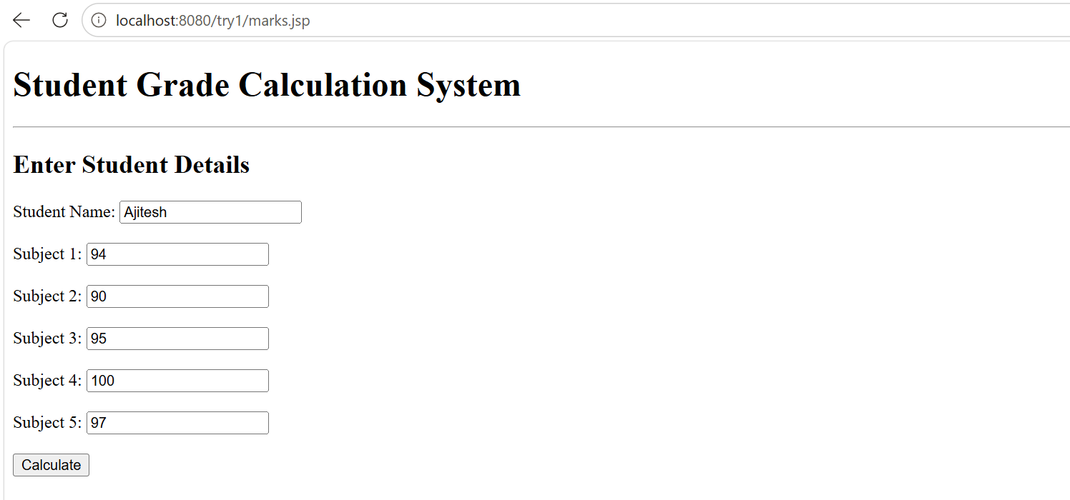
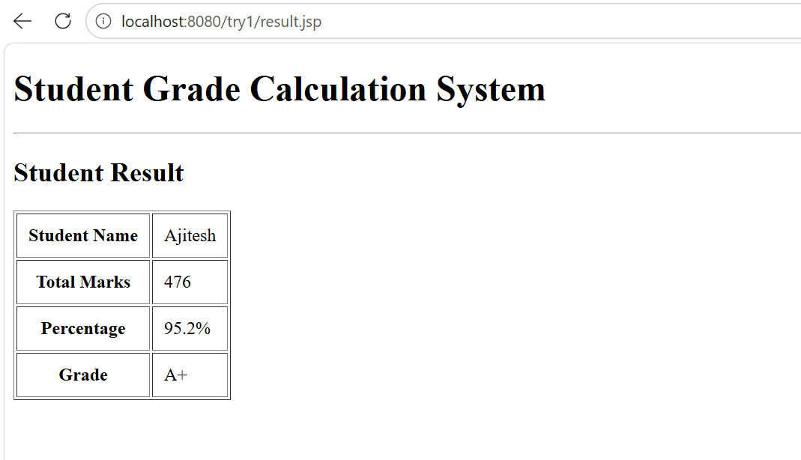

Q3
Q3.jsp
<%@ page language="java" contentType="text/html; charset=UTF-8"
pageEncoding="UTF-8"%>
<!DOCTYPE html>
<html>
<head>
<meta charset="UTF-8">
<title>Insert title here</title>
</head>
<body>
<form method="POST" action="q3">
ID: <input type="text" name="id">
<br><br>
NAME: <input type="text" name="name">
<br><br>
DEPARTMENT: <input type="text" name="dep">
<br><br>
SALARY: <input type="text" name="sal">
<br><br>
<input type="submit" name="submit">
</form>
</body>
</html>

Q3.servlet

import java.sql.*;
import java.io.IOException;
import java.io.PrintWriter;

import javax.servlet.ServletException;
import javax.servlet.annotation.WebServlet;
import javax.servlet.http.HttpServlet;
import javax.servlet.http.HttpServletRequest;
import javax.servlet.http.HttpServletResponse;

@WebServlet("/q3")
public class q3 extends HttpServlet {
private static final long serialVersionUID = 1L;

public q3() {
super();
// TODO Auto-generated constructor stub
}

protected void doPost(HttpServletRequest request, HttpServletResponse response) throws ServletException, IOException {
int id=Integer.parseInt(request.getParameter("id"));
String name=request.getParameter("name");
String dep=request.getParameter("dep");
double sal=Double.parseDouble(request.getParameter("sal"));
PrintWriter out =response.getWriter();
try {
Class.forName("com.mysql.cj.jdbc.Driver");

Connection con=DriverManager.getConnection("jdbc:mysql://localhost:3306/employeedb","root","");

PreparedStatement ps=con.prepareStatement("insert into employee values(?,?,?,?)");
ps.setInt(1, id);
ps.setString(2, name);
ps.setString(3, dep);
ps.setDouble(4, sal);
ps.executeUpdate();

Statement stmt=con.createStatement();
ResultSet rs=stmt.executeQuery("select * from employee");
out.println("<html><body>");

out.println("<h2>Employee Records</h2>");

out.println(
"<table border='1' cellpadding='10'>");

out.println(
"<tr>" +
"<th>ID</th>" +
"<th>Name</th>" +
"<th>Department</th>" +
"<th>Salary</th>" +
"</tr>");
while(rs.next()) {
out.println("<tr>");

out.println(
"<td>" +
rs.getInt("eid") +
"</td>");

out.println(
"<td>" +
rs.getString("ename") +
"</td>");

out.println(
"<td>" +
rs.getString("department") +
"</td>");

out.println(
"<td>" +
rs.getDouble("salary") +
"</td>");

out.println("</tr>");
}
out.println("</table>");

out.println("</body></html>");

con.close();

}catch(Exception e){
System.out.println(e);
}
}

}
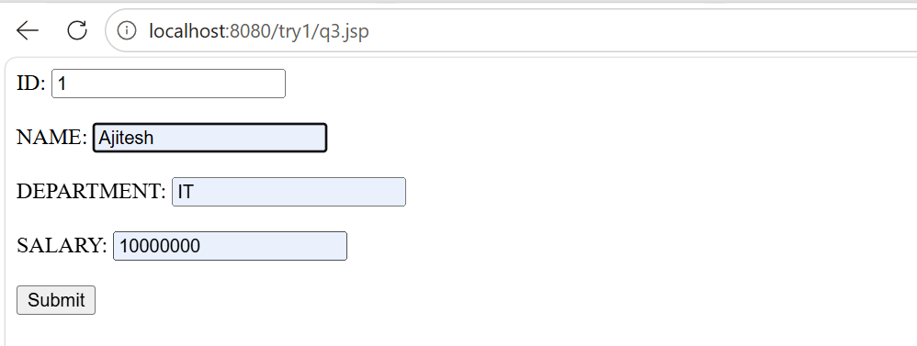
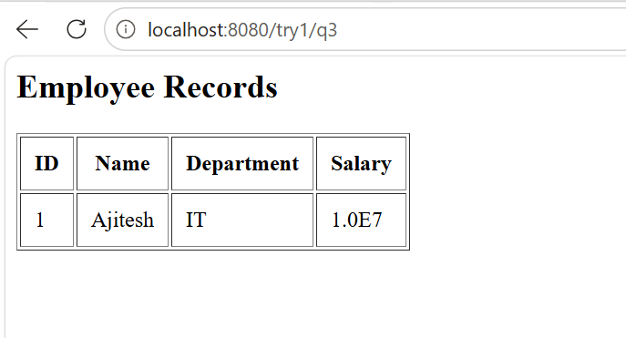

Q4
Models.py
from django.db import models

# Create your models here.
class Event(models.Model):
name=models.CharField(max_length=100)
location = models.CharField(max_length=100)
date = models.DateField()
is_active=models.BooleanField(default=True)
def _str_(self):
return self.name

views.py
from django.shortcuts import render
from .models import Event
# Create your views here.

def event_dashboard(request):
events=Event.objects.filter(is_active=True)

return render(request,'event_dashboard.html',{'events':events})

event_dashboard.html
<!DOCTYPE html>
<html>

<head>
<title>Event Dashboard</title>
</head>

<body>

<h1>Active Events</h1>

{% if events %}

<table border="1" cellpadding="10">

<tr>
<th>Name</th>
<th>Location</th>
<th>Date</th>
</tr>

{% for event in events %}

<tr>

<td>{{ event.name }}</td>

<td>{{ event.location }}</td>

<td>{{ event.date }}</td>

</tr>

{% endfor %}

</table>

{% else %}

<h3>No active events found.</h3>

{% endif %}

</body>
</html>
